How to: Get you Cookie from eurosport player:

1. Open the Web-developer tool in Firefox:

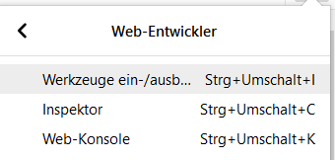

1. Go there to „Netzwerkanalyse“:



1. Open eurosportplayer.com and be login.
2. Search at the web-devloper-window:  
   <https://eu3-prod-direct.eurosportplayer.com/cms/collections/web-menubar?include=default>  
   or:  
   https://eu3-prod-direct.eurosportplayer.com/cms/collections/web-footer?include=default



1. Copy the Cookie on your left hand side:

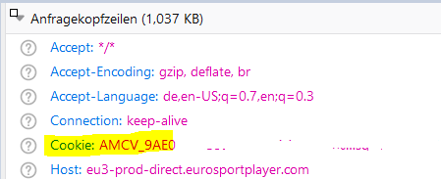

1. Open /resources/setting.xml and enter the cookie into line 8 between ‘‘ (line changed to 106!!!)

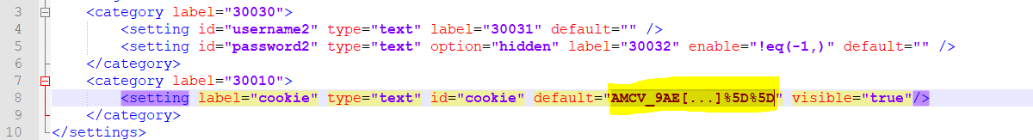

(Cookie is really long)